Qi Gong…
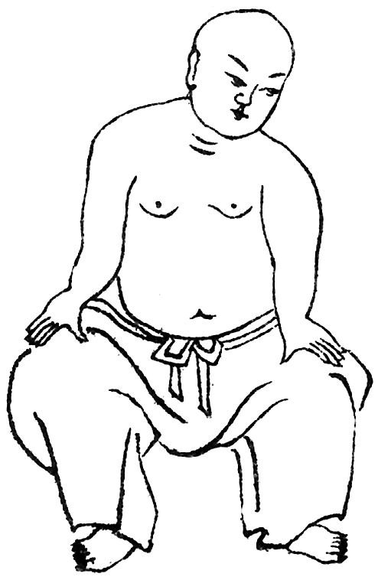
Internal Energy…

Shaolin Temple of the US
is having a class of
Internal Energy…

Ba Duan Jin 
Yi Jin Jing 
Soft Fist 
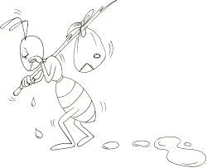

Let us practice
increasing the internal
power and release all
tendons of the whole day stress !

Register today !!!

At: 102-44 43rd Ave, Corona, NY 11368  718-651-3752 or  e-mail us at: info@shaolintemplezen.org

