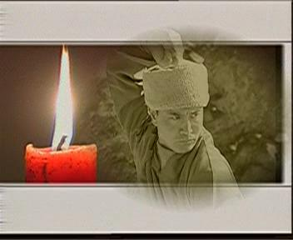
(De Jian)
De Jian is the fourth generation inheritor of the original Wu Gu Lun sect of the Shaolin Temple , and the 31st generation disciple of the Cao Dong sect of Ch'an Buddhism. He continues the traditional Shaolin culture, which includes the three treasures of Shaolin Temple : Ch'an, Gongfu and Medicine. My master has a very high moral standard and embodies the real Shaolin culture. He is a decent person, and does not allow the modern world to change his way of life. In recent years, the Chinese government has been trying to find out more about the ancient culture of China , that's how this sect of Gongfu and my master's name has become better known to people around the world.

Wu Gulun (Buddhist name Ji Qing) 1831 to 1914.
Wu Gulun was a great master of Shaolin Gongfu of recent times. He entered the Shaolin Temple when he was five years old. His master was Zhan Mo and he was given the Buddhist name of Ji Qing. At the beginning of the Qing dynasty the government outlawed the practice of Gongfu. The monks of Shaolin still kept training behind closed doors. Later, a general by the name of Ling Qing admired Shaolin Gongfu and he ordered the monks to demonstrate their secret skills. The monks were afraid of the general because martial arts were outlawed at that time. The monks left the Shaolin temple and some returned to a secular life. Master Ji Qing and his teacher Zhan Mo also left the temple at that time. They retreated to a small temple called Shi Guo Si where Zhan Mo taught Ji Qing the art of Xing Yi Ba, which is regarded as a high level skill. Ji Qing trained in many other Shaolin gongfu skills that included Qing Gong (light skill) Chi Gong (breath control). He developed Xing Yi Ba to the highest level and now he is regarded as the 1st generation master of this sect of Gongfu. At the Shaolin Temple the walls bear witness to the training of Ji Qing.
His picture can be seen on the wall paintings, the frescos, in the Guan Yin Hall at the Shaolin Temple . He is the monk dressed in blue and in a Tui Shou posture. It is written in the old Shaolin manuals that Ji Qing was the last monk to fight his way out of the Shaolin Temple against the 18 temple guardians. Ji Qing left with some Shaolin manuals and returned to a secular life. In 1928 the Shaolin Temple was burned and almost all the manuals on Gongfu and Ch'an Buddhism destroyed. After the fire in 1928 the original Shaolin Gongfu was almost lost. Fortunately Master Ji Qing and some of his followers were able to retain their sect of gongfu which includes Xing Yi Ba, the highest level of Shaolin Gongfu; thus the true lineage of Shaolin Gongfu continues to this day. This sect of Gongfu is a closely guarded secret. Only a few people in these modern times know this kind of Gongfu. In Chinese history Ji Qing is well known as a hero for his good deeds and moral character.

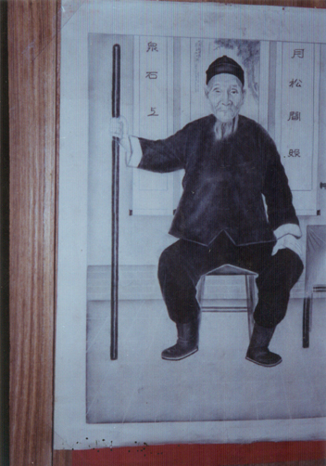
Wu San Lin, 1875 to 1970, 2nd Generation Master.
Wu San Lin was the second son of Wu Gulun and made a great contribution to Shaolin Gongfu. When Wu San Lin was young he began training Gongfu under his father Wu Gu Lun. He devoted his time and efforts to Ch'an Buddhism, Gongfu and medicine. He mastered many top skills of Shaolin Gongfu and reached the peak of Shaolin training. Much of the knowledge of the original Shaolin Gongfu was lost by the fire in 1928, so Wu San Lin was invited back to Shaolin Temple to teach; he taught De Gen and about 40 other monks. Because of the limited time, he taught at Shaolin Temple only three years, he taught the basics of Shaolin Gongfu and a few movements of Xing Yi Ba. At present, most people who claim to be the successors of Shaolin Gongfu received some of their knowledge from Wu San Lin.
Wu San Lin decided to leave Shaolin Temple because he felt some dissatisfaction with the temple life. It was his father's wish that Wu San Lin could take back the original Shaolin culture back to Shaolin temple. Before Wu San Lin passed away, he entrusted his closest disciple Zhang Qing He, Buddhist name Xing Xin, with the task of carrying on with the Shaolin teaching and restoring it back to the Shaolin Temple .
In the 1960s, the general secretary of China 's martial arts association Li Tian Ji came to Shaolin temple to do research on top traditional Shaolin skills. At that time, Wu San Lin was in his late eighties, but he was invited back to Shaolin Temple to demonstrate his Xing Yi Ba, and he amazed everyone.

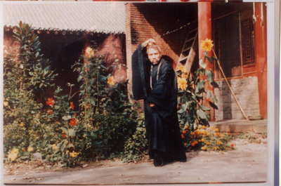
Zhang Qing He, 1931 TO 2004, 3RD Generation Master
The disciple of Wu San Lin, Zhang Qing He, was 9 years old when his parents passed away, he was very poor and forced to beg on the streets. In his later years he met a famous monk from Shaolin temple by the name of Chun Qian. Chun Qian, a disciple of the famous monk Ji Huan, was accomplished in gongfu and medicine, and was also the Buddhist doctor at the Shaolin Temple . Because of the bad behaviour of one of the monks, Chun Qian left the Shaolin temple and lived in a branch temple called Jing Gang Si. Master Chun Qian took Zhang Qing He as his son and taught him all his knowledge about Shaolin Gongfu and medicine. He recommended that Zhang Qing He study with Wu San Lin. When he met Wu San Lin, he knew he had found the right master and continued to train very hard under his guidance. Zhang Qing He was trained by two great masters and became the 3rd generation master of Xing Yi Ba. He obeyed his master’s command, and was a person of low profile and lived like a hermit. He devoted his whole life to preserve the real teachings about Gongfu and medicine and to develop it further. Master Zhang Qing He is well known in his hometown for his high morals and work in helping others. Master Zhang Qing He has developed his own medicine that has better results than normal medicine. He taught the secrets of real Shaolin Gongfu to Shi De Jian, who is a Buddhist monk from the Shaolin Temple and so the wish of Wu Gu Lun was fulfilled.
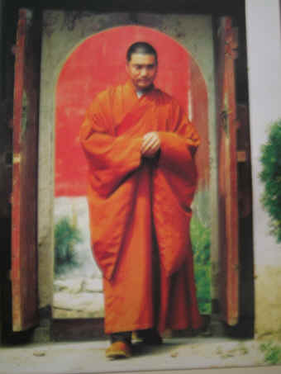
Shi De Jian, 4th Generation Master 2004
De Jian started to learn gongfu when he was very young. He first studied the Tai Zu form of Gongfu in his hometown with a master named Guan Ya Po. Later he studied with Chen Jin Su the art of Long Xin Ba Gua, which attacks the vital points of the human body and also has healing properties. Chen Jin Su, when she was young, was a Buddhist nun in Yu Fo Si in Shanghai . She was also the 11th generation master of Long Xin Ba Gua Zhang. In the 1930s Chen Jin Su used to challenge people for a fight, so that she could test her Gongfu skills but no one was able to beat her. Chen Jin Su liked De Jian's moral character and passed on all her skills to him. Before he came to Shaolin, he learned Tai-Ji and Xin Yi with Quan Guang Xin, and learned Chen style Tai-Ji with Chen Zhao Pi. In 1989, he came to Shaolin to further his Gongfu training. He first learned with Yang Gui Wu and Qiao Hei Bao for many years, and then he met Zhang Qing He, the 3rd generation master of the orthodox Shaolin gongfu of Wu Gu Lun. In order to bring back the original Gongfu to Shaolin temple, De Jian became an official Buddhist monk under grandmaster Shi Su Xi in 1990. After studying hard for 15 years with his master Zhang Qing He, De Jian finally succeeded and became the 4th generation master of the Wu Gu Lun sect of Shaolin Gongfu.
De Jian thinks it is his duty to preach Buddhism and help those in need. De Jian has donated all his money from curing people to renovate the temple on San Huang Zhai. De Jian is very soft hearted, and he is always very busy in helping people and giving advice on Buddhism. He believes that much value should be placed on the basic precepts of Buddhism and that these should be followed without seeking reward. My master is indeed a good example of a genuine Buddhist monk.

Information supplied my Xing An secular disciple of De Jian.
Translated my Raju Miah

