I TRUST THIS WILL MAKE THE ROUNDS THROUGH OUR MILITARY COMMUNITY.

Obviously, it's a picture in a cemetery. What cemetery and whose grave?
Sadly, it's the grave of Casey Sheehan. After two years, and a DoD payment of $250,000 to the "Peace Mom", Cindy Sheehan has not had the time or bothered to have a headstone placed on this young hero's grave. And, she doesn't even have to pay for one, the DoD will provide one:
"The Department of Veterans Affairs (VA) furnishes upon request, at no charge to the applicant, a government headstone or marker for the grave of any deceased eligible veteran in any cemetery around the world. For all deaths occurring before September 11, 2001 , the VA may provide a headstone or marker only for graves that are not marked with a private headstone.
Flat markers in granite, marble, and bronze and upright headstones in granite and marble are available. The style chosen must be consistent with existing monuments at the place of burial. Niche markers are also available to mark columbaria used for inurnment of cremated remains."
Apparently she can find time to protest on at least 3 continents, get arrested various times, go on vacation in Hawaii, have photo ops with the Marxists in Venezuela, but can't seem to find the time to properly mark her son's grave.
Ever wonder what the expression "stuck on stupid" meant?
Well here is an example:
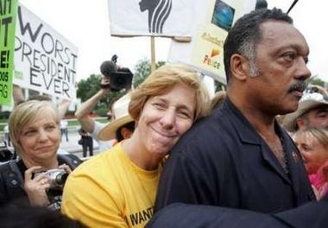
The grinning idiot clinging to Je$$e Jack$on is Cindy Sheehan... the stupid half wit protesting the war at Bush's ranch, who lost her son in the war, the same son she gave up in her divorce when he was 7 years old.
And by the way if you wonder why she has so much free time ... she is going through another divorce right now and guess what? She is giving up custody of another son.
As Forest Gump once wisely proclaimed, "Stupid is as stupid does."

